1. **Insights : Lead Source Distribution**

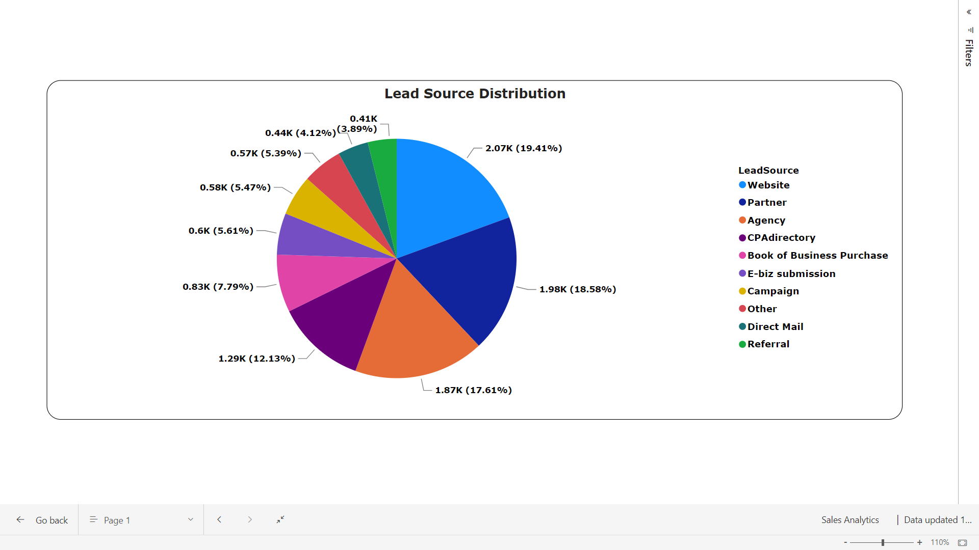

**Websites**, **Partners**, **Agencies** and **CPAs** generate substantial opportunities.

**2. Insights : Lead Source v/s Annual Revenue**

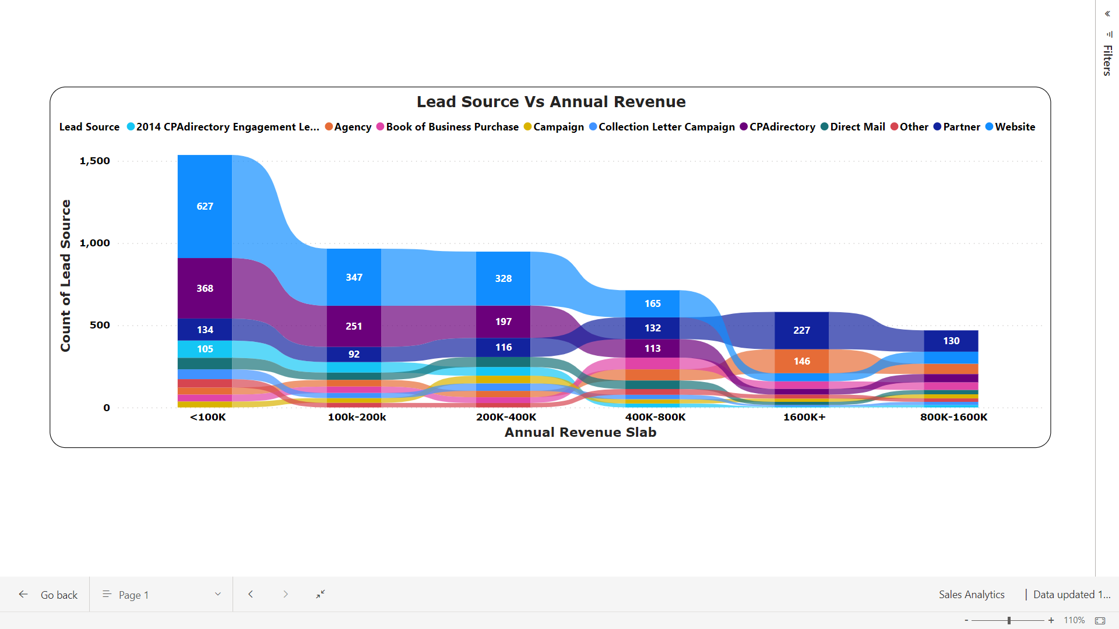

**Strategic Annual Revenue Opportunities:**

* Utilizing the **Website**’s true **potential** can convert a lot of opportunities across all revenue slabs.
* On the **higher revenue side** we can improve our focus on **agency** and **partner** for converting opportunities.

**3. Insights : HeatMap for Lead Source(X) vs Annual Revenue(Y)**

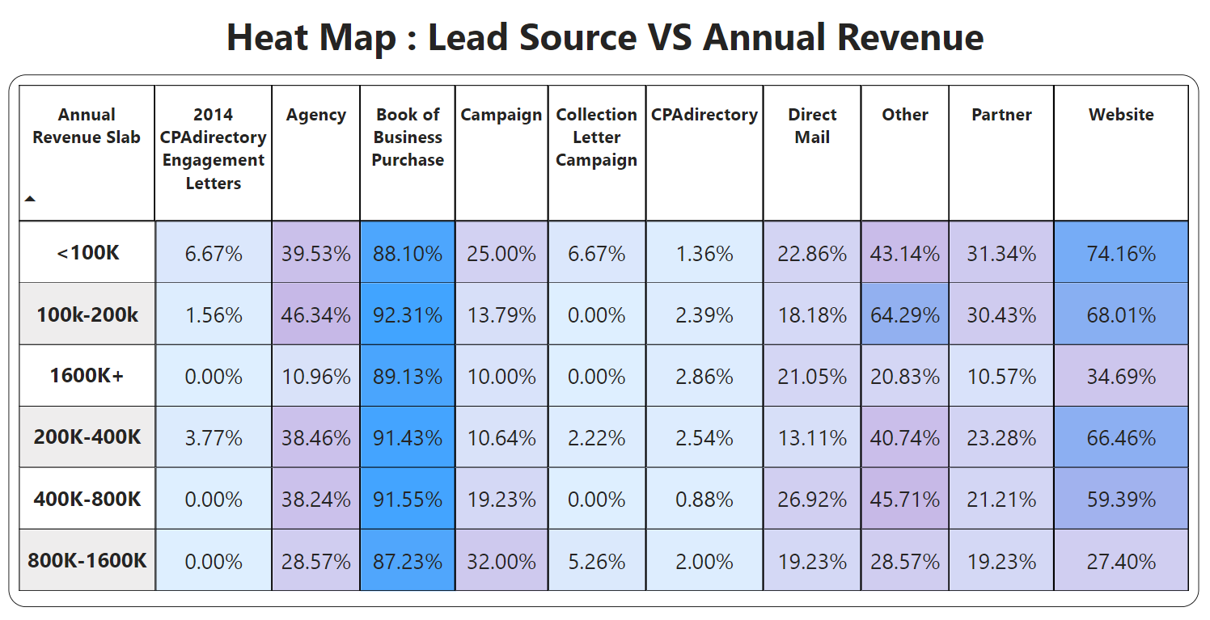

* **Leverage** the success of **Book of Business Purchase** and **Referrals** by allocating additional resources and marketing efforts towards these channels.
* Alarmingly low conversion ratio for **CPAdirectory**. Need to **investigate** and **optimize** our approach on CPAdirectory.
* Tailor approaches for **high-revenue leads** across various sources, personalized incentives or specialized engagement strategies to improve conversion rates.
* Evaluate and refine the **website**'s engagement process, possibly by introducing targeted offers or user-friendly features.

**4. Conversion Comparison for Cities in CA**

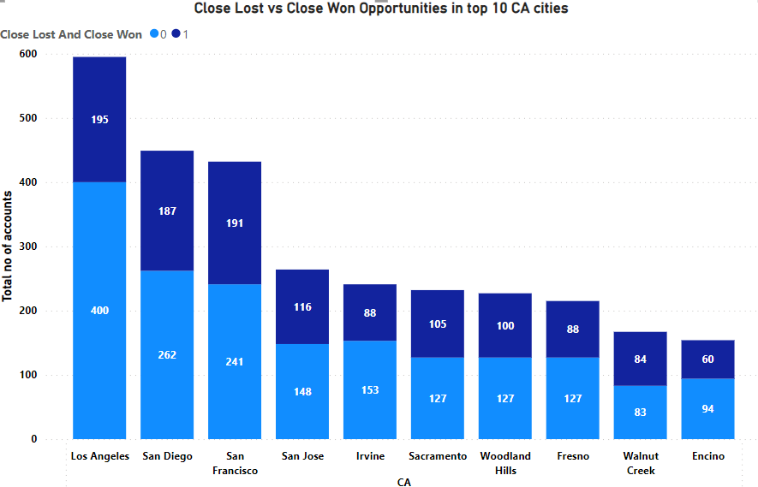

* **Los Angeles**, **San Diego** and **San Francisco** cities showcase abundant opportunities, but exhibit lower success rates.
* Exploring strategies to optimize our approach in these key markets can enhance our performance.

**5. Conversion Ratio v/s Number of Employees**

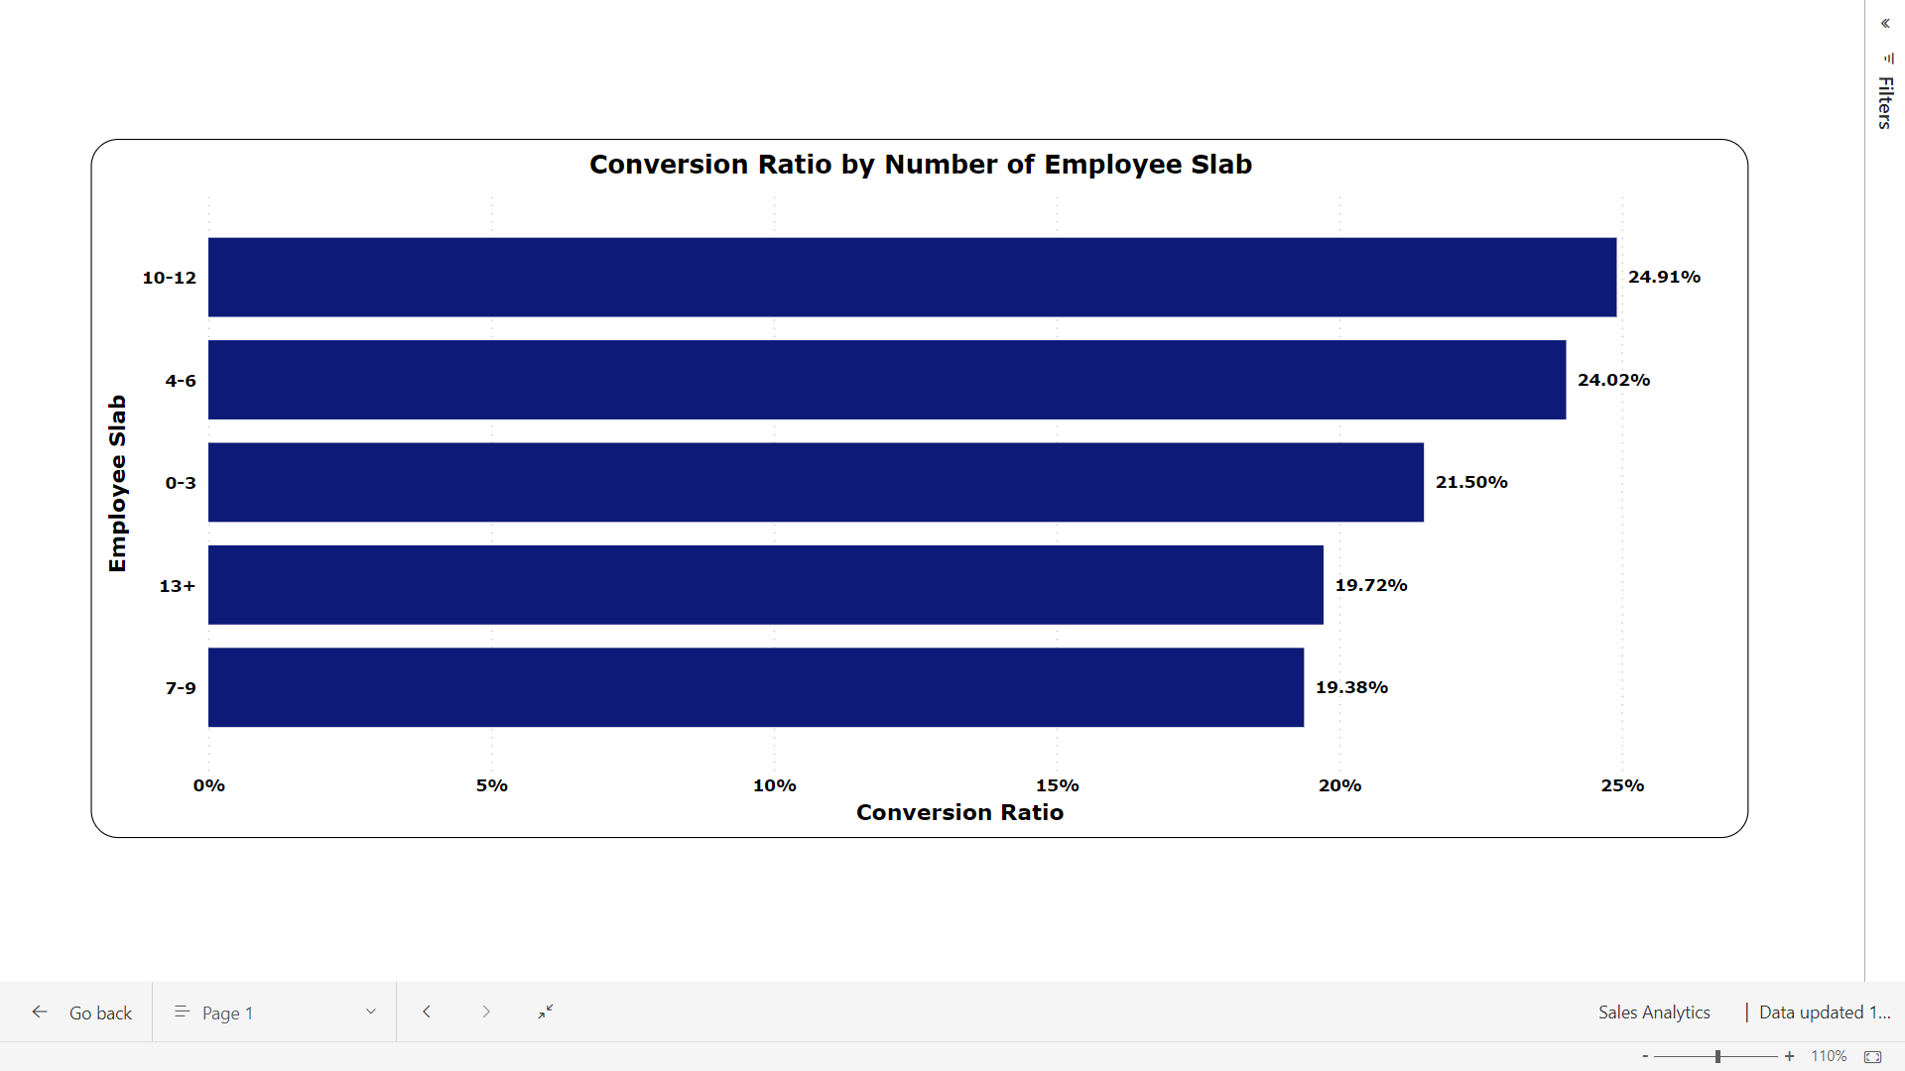

The changing scenario of the **number of employees** leads to a fluctuating conversion ratio.

**6. Insights : Entity Type Distribution**

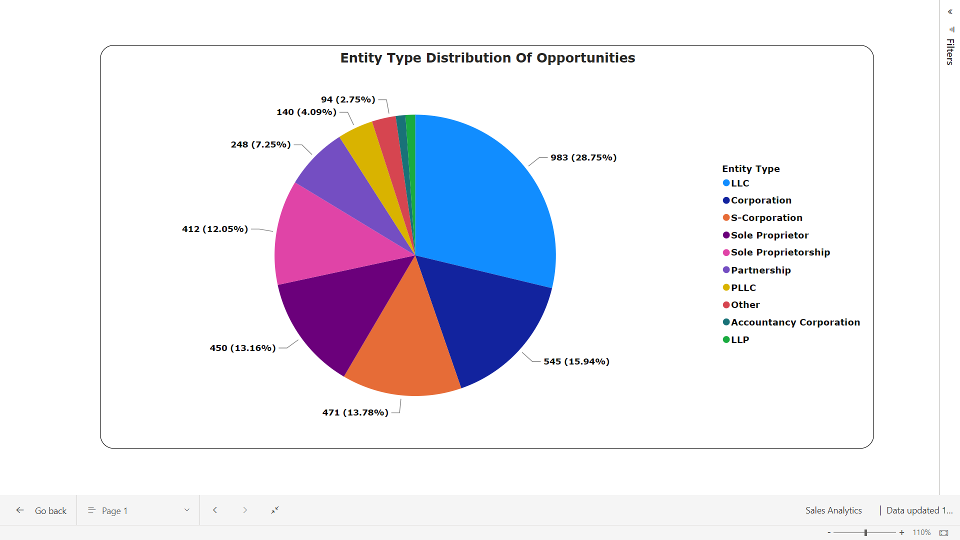

* **LLC**, **Sole Proprietor** and **S-Corporation** has given a business boost and lead us to a lot of opportunities
* A **good strategic planning** ensures effective positioning and engagement across these entities, maximizing opportunities in each business entity category.

**7. Insights : Different entity types**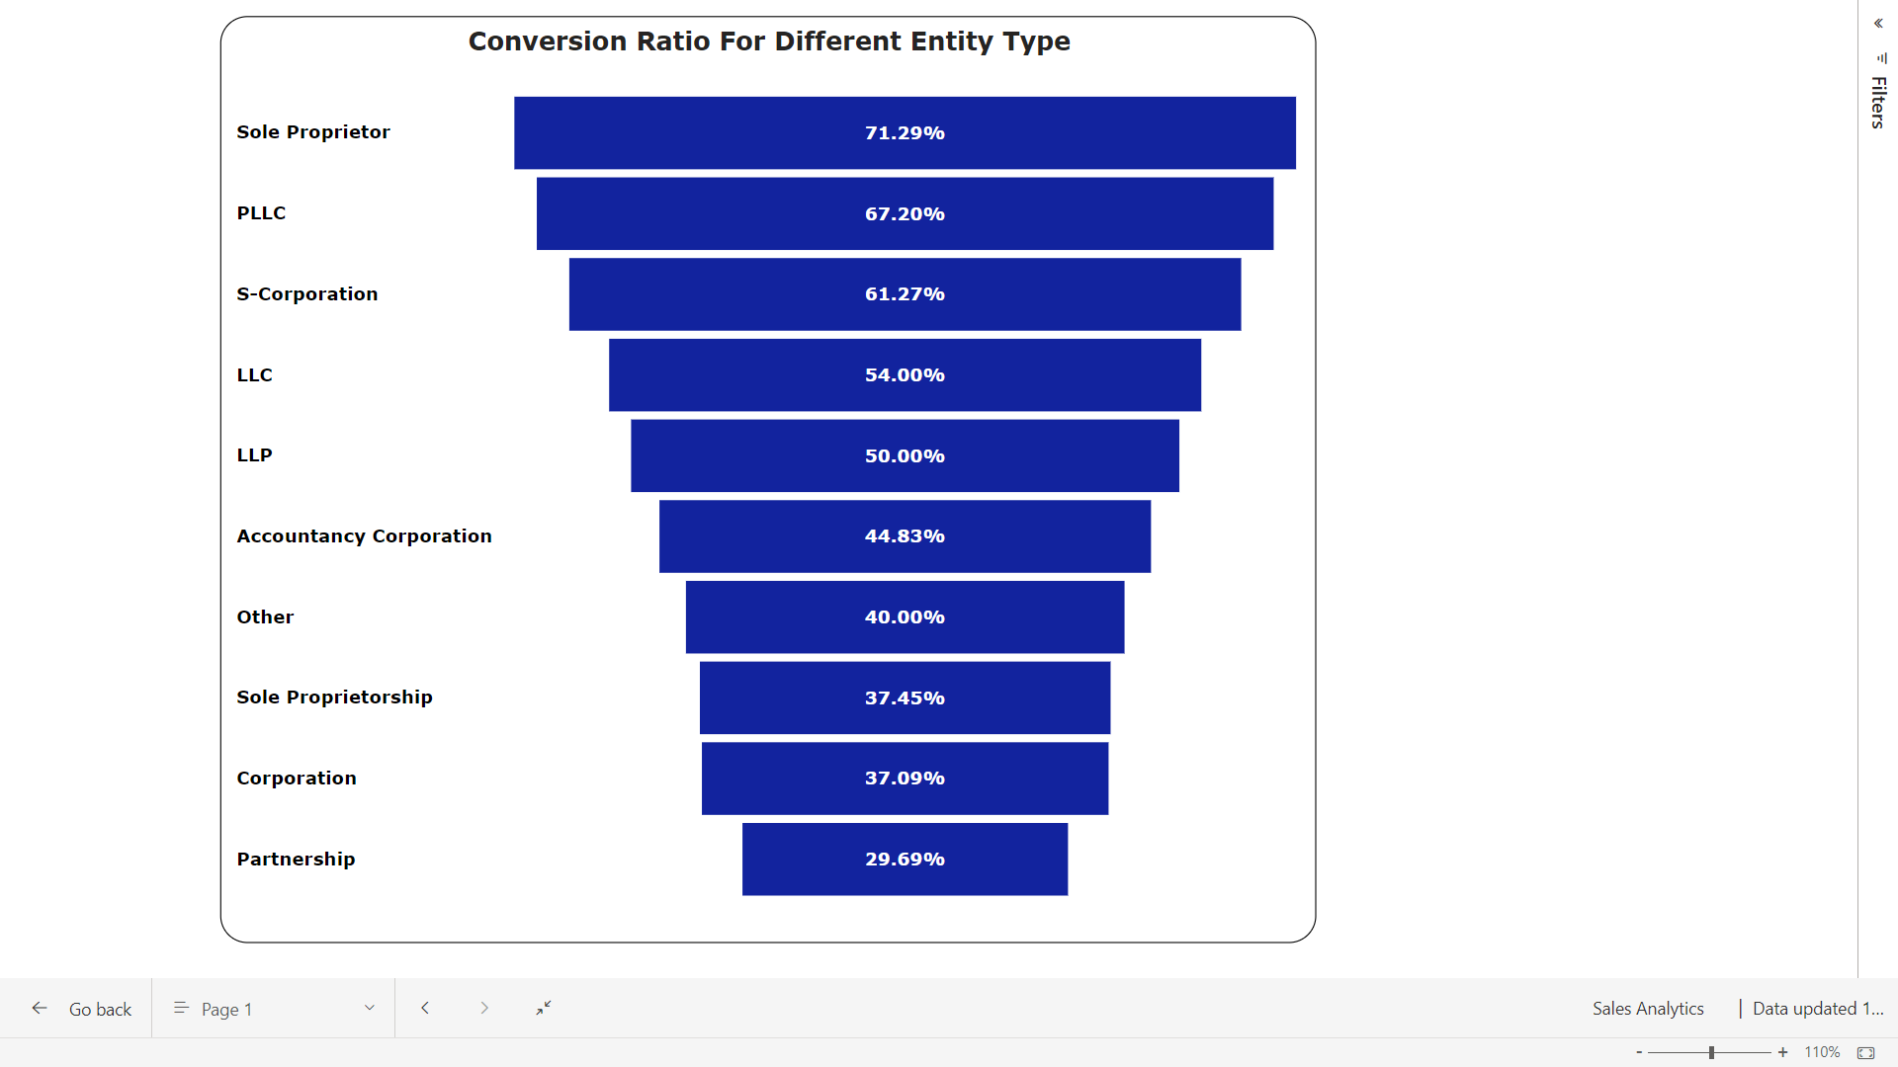

* **Corporations** create lots of chances, but they don't always turn them into success.
* **Sole Proprietors**, **PLLC**, **LLC** are doing great. They not only grab opportunities but also turn them into wins. So these entity types convert a lot more opportunities by better planning and focusing.

**8. Insights : Different business types**

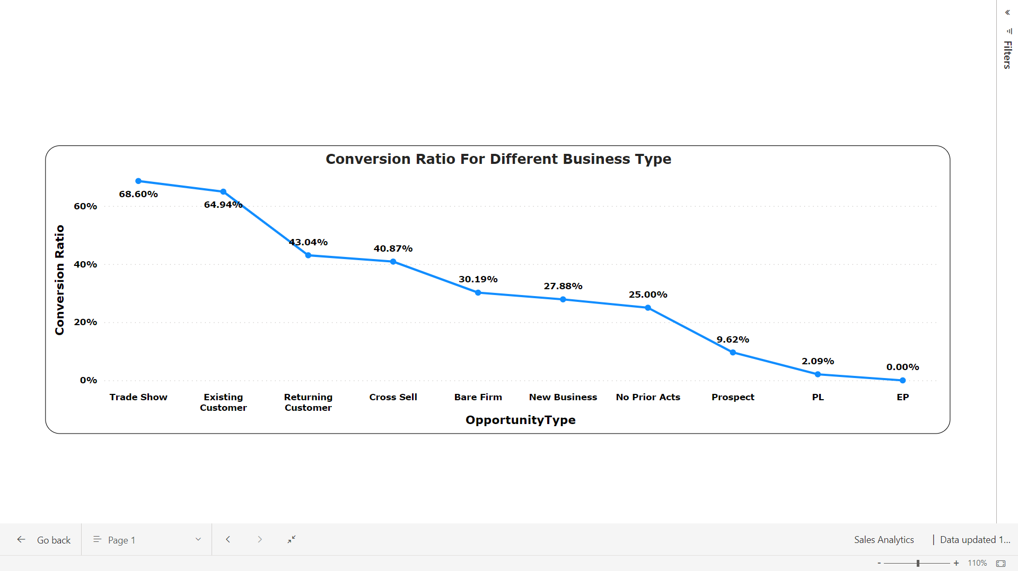

* **Bare Firms** and **New Businesses** significantly contribute to more generation but face a lower conversion rate.
* Strategically tailoring conversion strategies for these segments is recommended to enhance overall **sales effectiveness** and optimize performance.

**9. Insights : New Businesses**

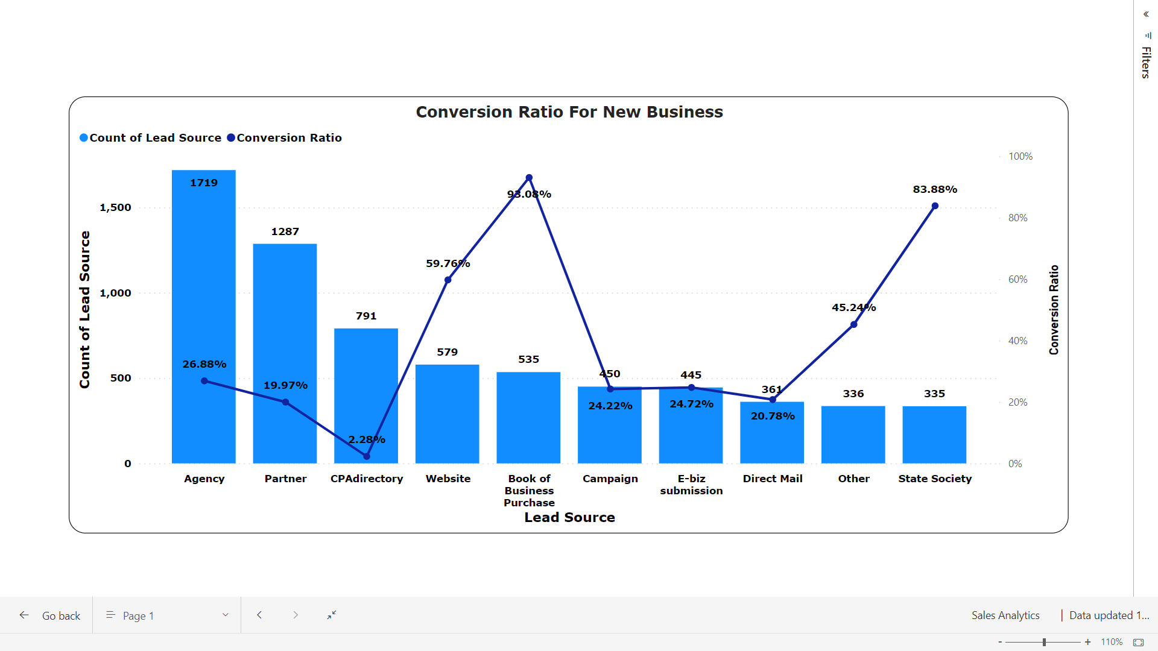

**Strategic Focus for Lead Generation and Conversion:**

* Prioritize **high conversion ratio** sources like **Books of Business Purchases**, **Websites**, and **State Society**.
* Optimize strategies for **higher account number sources**, including **Agency**, **Partner**, and **CPAdirectory**.
* Emphasize **improving conversion rates** by enhancing **lead quality** and refining sales approaches.

**10. Insights : Bare Firms**

* **Evaluate performance metrics: CPAdirectory**, though with a lower conversion ratio, is the **second-highest contributor**; the **Website** leads in both **contribution** and **conversion ratio**. 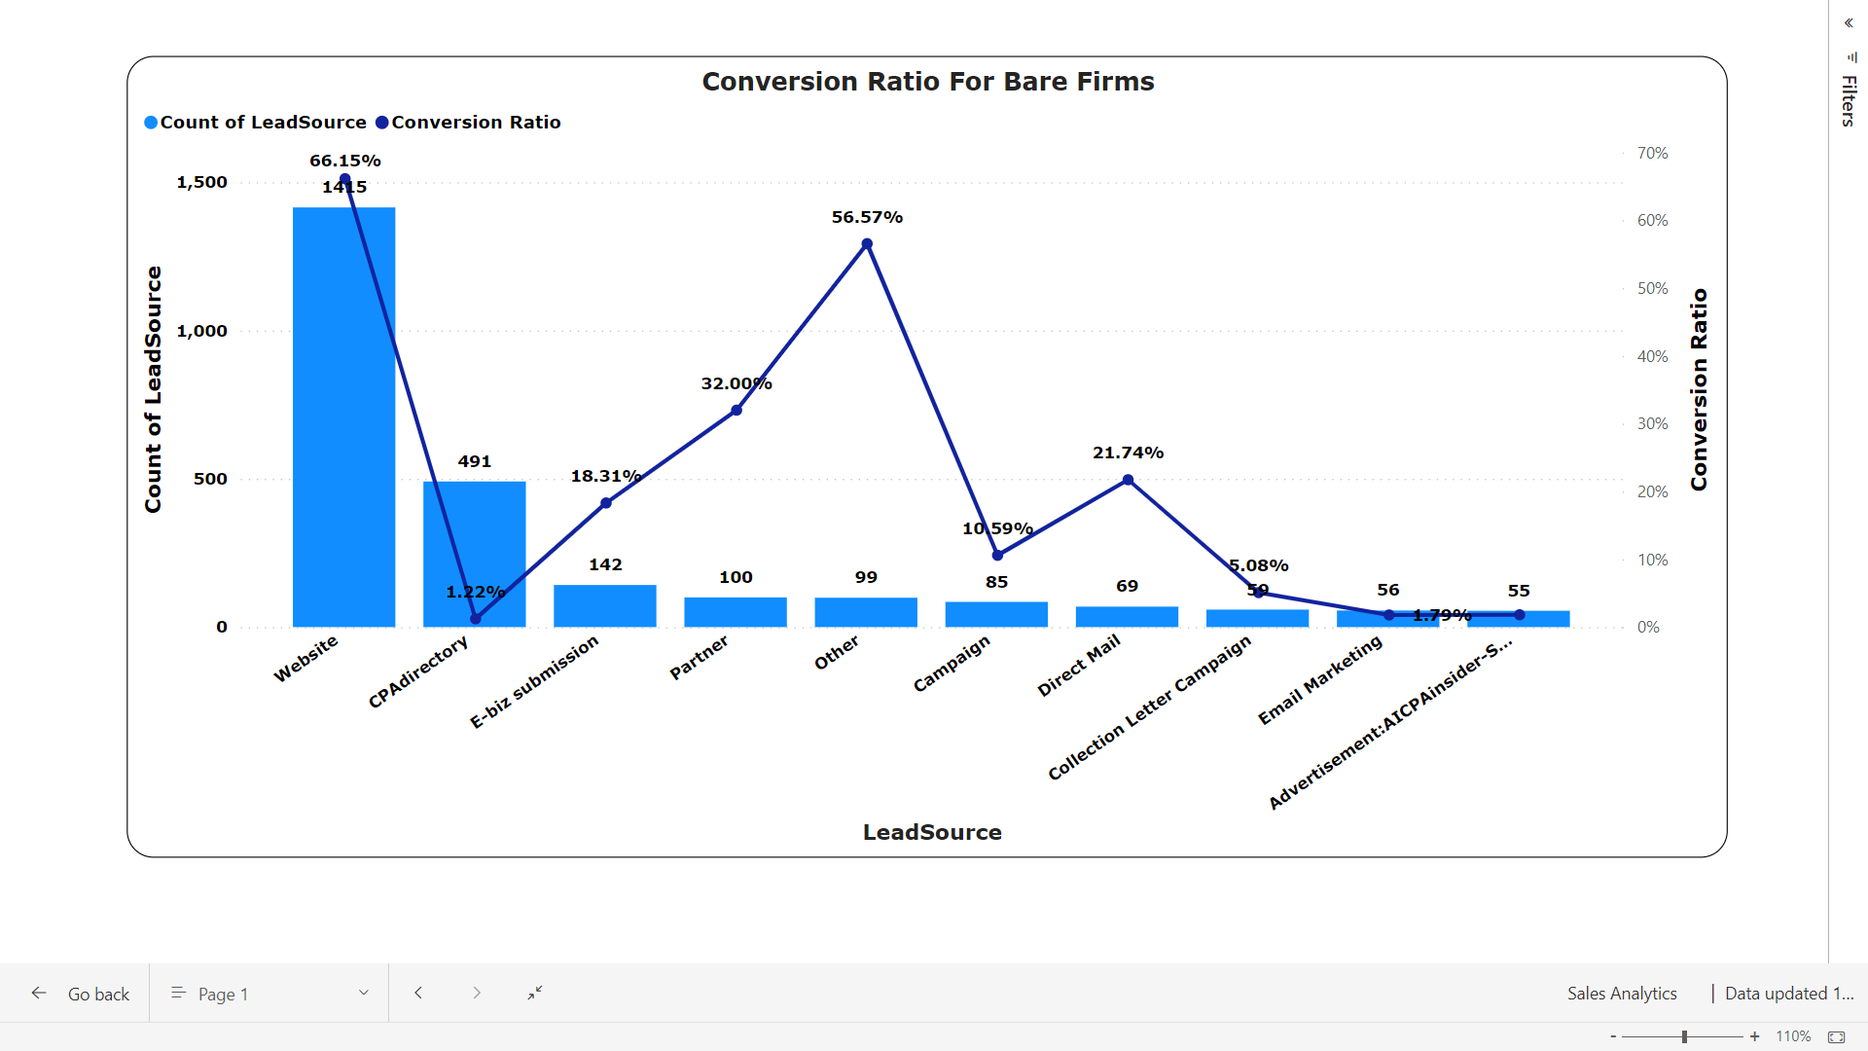
* Strategically, prioritize enhancing **CPA directory's conversion rate** while consistently maintaining and improving the **Website's performance**. A balanced approach ensures optimal overall sales effectiveness.

**11. Insights : Top 10 popular states**

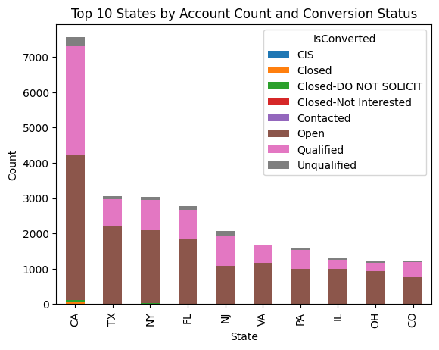

* **Focus on high-lead volume states:** **California**, **Texas**, and **New York**. Direct sales efforts and formulate targeted strategies for these regions.

**12. Insights : Contact title v/s time**

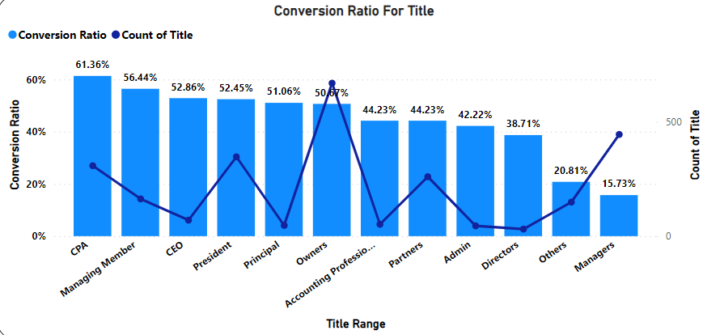

**Lead Title Dynamics:**

* **High contact volume** for titles like Owner, Mr., **President**, **Partner**, and **CPA**.
* **CEO**, **Managing Manager**, and **Sole Proprietor** show higher conversion percentages, signaling **successful closures**.

**Time-Conversion Relationship:**

* Average opportunity conversion time: **174 days**.
* **Inverse relationship** between time taken and conversion chances, emphasizing the need to optimize processes for quicker conversions and enhance overall sales outcomes.

**13. Trends about annual revenue by business types**

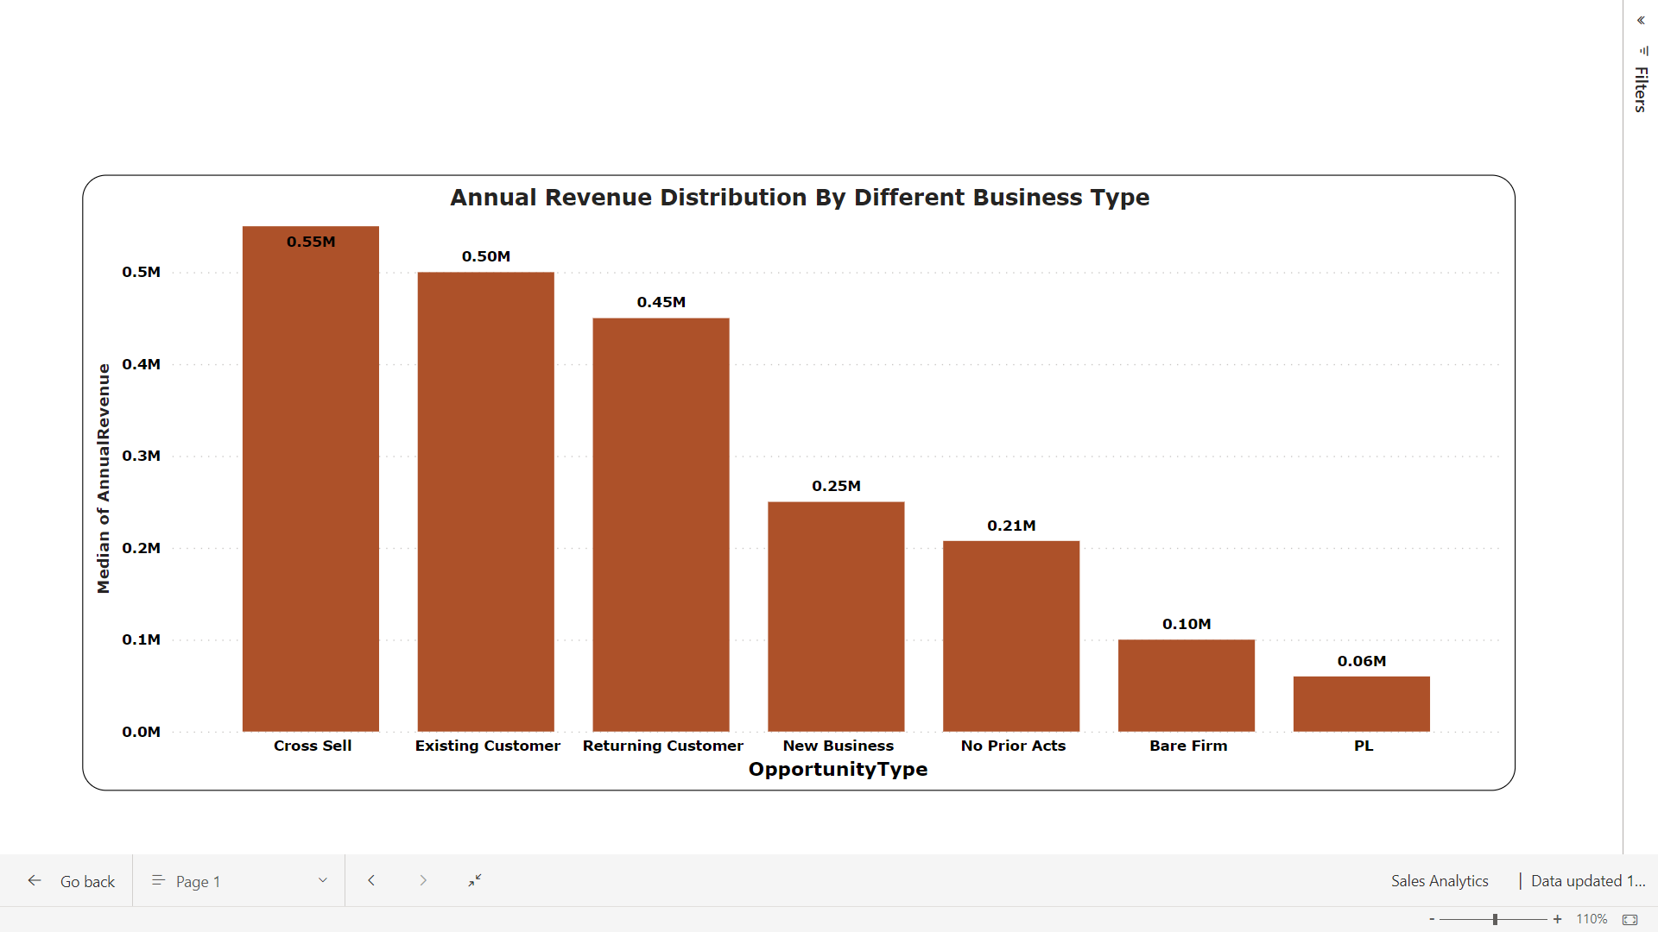

The trend shows **EP**, **cross sell** and **returning customers** has a **market dominance** and are capable of converting **higher revenue opportunities**.

**14. Heat Map : Billing State VS Opportunity Type**

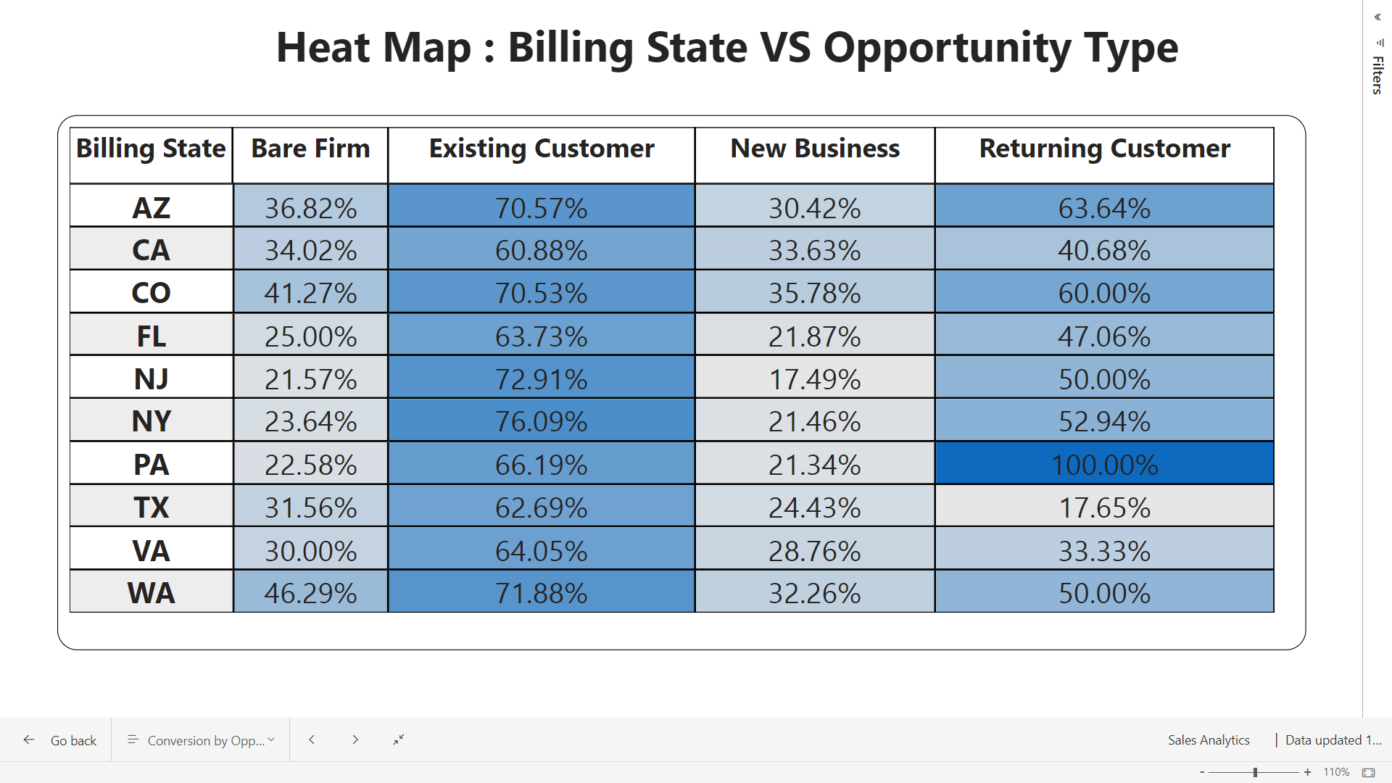

* Most of the States are not performing well for **new businesses** and **bare firms**.
* **TX** and **VA** struggle with **customer retention**.
* **Customer retention** rate is high in **PA**, **AZ**, and **CO**.